Rats
- Dread Pyrate
- Member

- 1,095 posts
- Gender:Male
- Location:Whitewater WI.
- Interests:Theft, brigandry, pilfering and bad grammar
Posted July 1, 2007 · Report post
I'm not sure if this was ever brought up. But I'm wondering what the average wages were for common folks (Not just mariners) and also common exchange rates.
What was a good silver spoon worth??
What was a bushel of apples or a bail of hay worth??
A side of ham or a chicken??
How much was a meal or a tankard of port??
Any people in the know out there???
Thanks in advance!
Rats

MorganTyre
- First Mate
- Member

- 291 posts
- Location:South Texas
- Interests:Sailing, rigging, snorkeling, spearfishing, diving
Posted July 1, 2007 · Report post
Here's the Port Royal probate site. It'll give you approximate values.
Probates
I'm not sure what the wages were at the time. I put together the following exchange table some time ago - I doubt it's remotely accurate but it'll point you in the right direction
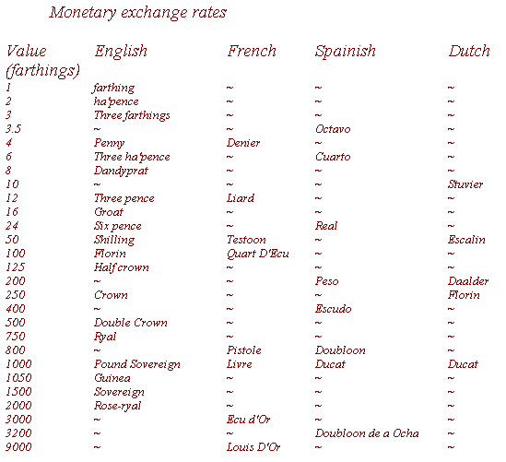

Fox
- Old Twillian
- Moderator

- 2,564 posts
- Gender:Male
- Location:Beautiful lush Devon, England
- Interests:Nautical history of the 16-18th centuries and living history based thereon.
Shooting pirates.
Posted July 1, 2007 · Report post
OK, let's start with the basics. Rates of pay in 1700 RN establishment went from 18s per lunar month for landsmen (19s for seamen, £1 4s for able seamen), through £2 10s per month for a boatswain on a fourth rate to £28 for a captain of a first rate.
In merchant ships wages were usually a little higher for the crew, particularly in wartime, for example, the crew of the Hopewell in 1679 were paid from 15s for the cook to £1 15s per month for the seamen. The mate was paid £2 5s, the boatswain £2, and the master only £2 10s.
Still naval, but not mariners, the nurses and laundresses on the hospital ships were paid the same rate as an able seaman. On shore the labourers in Royal dockyards were paid 1s 6d per day, equivalent to £1 16s per month, while more skilled worker like joiners and masons were paid 2s 6d, or £3 per month.
We can get some idea of the cost of some things from documents detailing the supplies for some military unit, such as the Admiralty Slop Contract specs. In 1696, fo example, a cavalry trooper's coat cost £3 10s (£4 10s for a corporal's coat), but his sword only cost 10s. Dragoons were less well equipped; their coats only cost £2 2s, and their swords a mere 7s 6d.
Probate inventories can also give us a good idea of the value of things:
1 gray Coat, 12s 6d
1 blak hatt, 10s
one mountere Cap, 5s
2 ould lynes wth. Hooks & leads &reels, 5s
1 od boot, 6s
a bedsack & Rugg, 5s 6d
four yards Canvas, 1s
a cheste, 1s 6d
1 fowlinge peece, 2li
One Bible, 4s
1 booke ye voice of ye rod, 1s 4d
3 shurtts, 12s
1 Rasur & pr of sisurs & half of a hone, 2s
23 duz of pypes, 5s
1 hatchet & old hamer, 2s
two blankits, 7s 6d
a payre of shoos, 5s 6d
2 hhs of brandy, 20 li
a Gooners Scale & hights & compases, 10s
2 paier of striped briches, 1li 2s
1 Cloth Coat, 15s
1 Red wastkott with silver lases, 15s
sea booke, 5s
barrel of Rum, 30 gallons, 3li
a negroe woman, £27
1 chest of draws, £3
2 Horses, £12
2 old crosscut sawes and a handsaw, 8s
One Sloope named Mary, £168
A load stone & a sea charte, 7s 6d
6 old Knives, £1 10s 1/2d
(Picked at random from various probates, 1660-1736)
For international exchange rates, here's a quotation from an earlier thread:
"... allow me to summarise the "Royal Proclamation regulating the value of foreign coins (18 June 1704)"
Seville pieces of eight, old plate = 4s 6d
" , new plate = 3s 7d 1 farthing
Mexico pieces of eight = 4s 6d
Pillar pieces of eight = 4s 6d 3 farthings
Peru pieces of eight, old plate = 4s 5d (or thereabouts)
Cross dollars = 4s 4d 3 farthings
Ducatoons of Flanders = 5s 6d
Ecus of France, or silver Louis = 4s 6d
Crusadoes of Portugal = 2s 10d 1 farthing
Three guilder pieces of Holland = 5s 2d 1 farthing
Old rix-dollars of the Empire = 4s 6d"

Littleneckhalfshell
- Plunderer
- Member

- 390 posts
- Gender:Male
- Location:Hudson Valley, NY
- Interests:Blacksmithing, hunting, fishing, stuff.......
Posted July 1, 2007 · Report post
http://www2.census.gov/prod2/statcomp/docu...CT1970p2-13.pdf
On this site, pages 45 and 46 have statistics for the Colonies from 1621 to 1781 for 'Daily Wages of sleected types of workmen' for instance a carpenter in Va. could expect 5 shillings a day if board was not furnished. There is also a chart for agricultural workers and a chart for common prices for standard commodities 1720-1775. for instance a bushel of corn would run you 1.73 shillings in 1720

Rats
- Dread Pyrate
- Member

- 1,095 posts
- Gender:Male
- Location:Whitewater WI.
- Interests:Theft, brigandry, pilfering and bad grammar
Posted July 1, 2007 · Report post
so 1 shilling is like 50 dollars (farthings) or is it more like a penny?
5 shillings =1 crown or 250 farthings (dollars)??
What is the d? A dandyprat??
I suppose even in early colonial America the common man was more apt to work in farthings and shillings or simple barter??
Was it common not to accept foreign currency???
What about bank notes, letters of debt and such??
Any examples???
Again thanks for the information!! This will all help with living history and working toward a steady portrayal!
Rats

Littleneckhalfshell
- Plunderer
- Member

- 390 posts
- Gender:Male
- Location:Hudson Valley, NY
- Interests:Blacksmithing, hunting, fishing, stuff.......
Posted July 1, 2007 · Report post
prices and wages were usually in Pounds Sterling (the funny L shaped thing) , Shillings ( s ) and pence ( d ) So in answer to "what is the d?" no it is not a dandyprat, but a pence.

Littleneckhalfshell
- Plunderer
- Member

- 390 posts
- Gender:Male
- Location:Hudson Valley, NY
- Interests:Blacksmithing, hunting, fishing, stuff.......
Posted July 1, 2007 · Report post
of note also, is that people were paid different wages depending if board was included or not, also some workers were paid in product, such as farm workers may have been paid in tobacco, not actual cash. Mention is also made on the site I provided earlier, that often the pay was in 'script' ie. paper money and not actual coin. There was a real coin shortage back then (maybe because so much was being taken by pirates)

Rats
- Dread Pyrate
- Member

- 1,095 posts
- Gender:Male
- Location:Whitewater WI.
- Interests:Theft, brigandry, pilfering and bad grammar
Posted July 1, 2007 · Report post
Rats!!!
The link is in Acrobat, which for some reason... Bogs down my computer????
Anyway you can list some of this here on the site???
Sounds like it's exactly the material I was looking for!
Thanks again to everyone!

Fox
- Old Twillian
- Moderator

- 2,564 posts
- Gender:Male
- Location:Beautiful lush Devon, England
- Interests:Nautical history of the 16-18th centuries and living history based thereon.
Shooting pirates.
Posted July 1, 2007 · Report post
Farthing = 1/4 of a pence
Shilling = 12 pence
Crown = 5 shillings
Pound = 20 shillings
guinea = 21 shillings
I believe the earliest banknote issued by the colonies was that printed by the Massachusetts Bay Company in 1690, for 2s 6d. Kass sells repros.

Matty Bottles
- Notorious Pyrate
- Member

- 891 posts
- Gender:Male
- Location:Milwaukee, WI
- Interests:Writing, Art, Spending exorbinant amounts of money on action figures, rum, murder.
Posted July 1, 2007 · Report post
I can't find anything on her site about the repro script...
Mr. Foxe, do you know any places that sell repro coins? There's about three coins, I think, available on Jas. Townsend.

Littleneckhalfshell
- Plunderer
- Member

- 390 posts
- Gender:Male
- Location:Hudson Valley, NY
- Interests:Blacksmithing, hunting, fishing, stuff.......
Posted July 1, 2007 · Report post
items from the Dept of Census, site said tables could be copied, so here they are.
http://i175.photobucket.com/albums/w132/li...entennialed.jpg
http://i175.photobucket.com/albums/w132/li...eprices1720.jpg
http://i175.photobucket.com/albums/w132/li...s1621to1781.jpg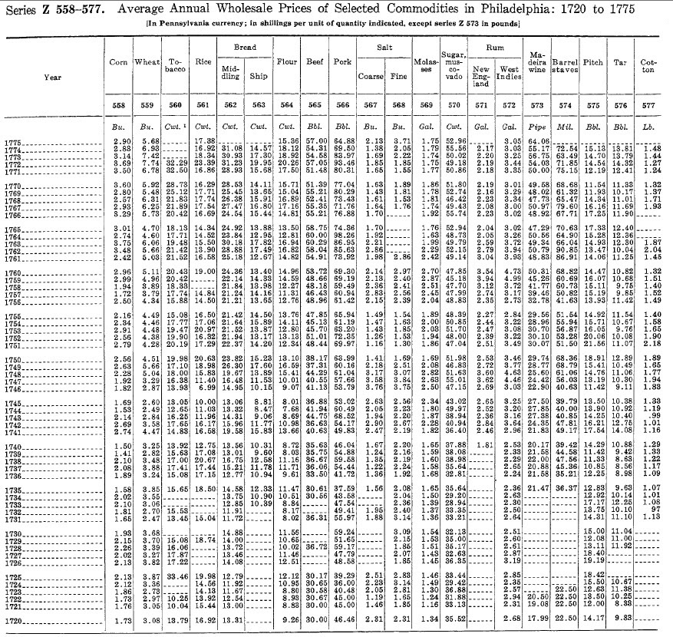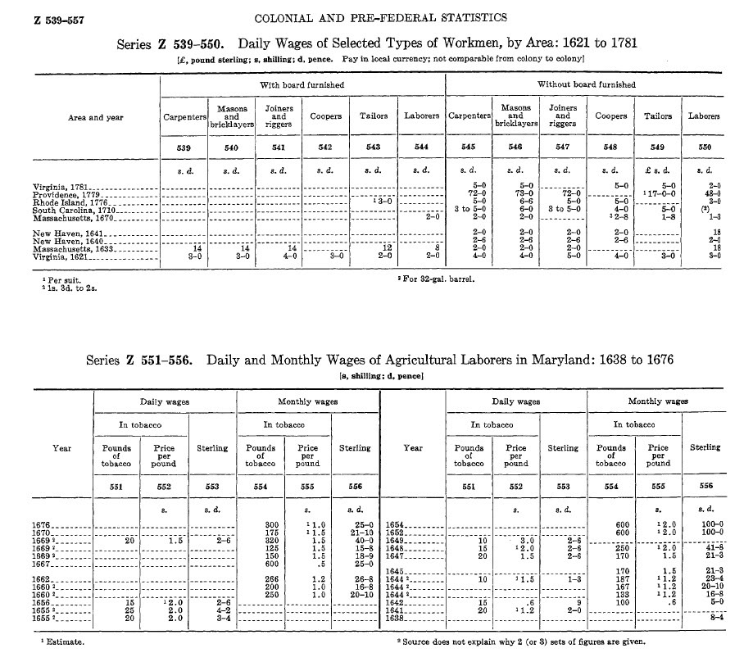

Rats
- Dread Pyrate
- Member

- 1,095 posts
- Gender:Male
- Location:Whitewater WI.
- Interests:Theft, brigandry, pilfering and bad grammar
Posted July 1, 2007 · Report post
Excellent !!!!
This will all work great!!!
Rats

MadMike
- First Mate
- Member

- 251 posts
- Location:Careened near the Gulf of Mexico
- Interests:1712 raid on Dauphin Island, Alabama.
Posted July 5, 2007 · Report post
From Wikipedia-
"The pound has only been divided into 100 pennies since 1971. Before this time it was divided into 20 shillings. Each shilling was divided into 12 pennies.
The symbols for shilling and penny came from Roman coins: "s" for shilling (from the Latin word "solidus" and "d" for penny (from the Latin "denarius"). The penny was divided into 4 farthings. The farthing became obsolete (was no longer used) in 1961 because it was worth so little."
Yours, Mike

Brit.Privateer
- Old Twillian
- Member

- 246 posts
- Gender:Male
- Location:North Carolina
- Interests:Atlantic World Maritime History during the Colonial Era. I specialize in early provincial era (1680-1740) and do quite a bit with pirate history.
Posted July 23, 2007 · Report post
I found something interesting in my book "Ships and Science, The Birth of Naval Architecture in teh Scientific Revolution, 1600-1800" by Larrie D. Ferreiro. In the "terms, symbols, units of measure, and money" section:
I provide 2002 U.S. dollar equivalents for most prices cited in the text. Although it is very tricky to convert the money of two and three centuries ago to present values (not only were the commodities different-e.g., horses versus cars-but the proportions of salary spent on, say, housing and food were poles apart), economists have developed estimates of inflation that permit a rough comparison of currencies. The two principal currencies of the period were the French livre tournois (literally, the pound of the city of Tours) and the British pound sterling. Currency conversoins vary by year, so to simplify matters I take the midpoints of the two centuries under study (1648 and 1750) as an average value for each century.
Approximate values in U.S. dollars (2002)
1600s____1 pound sterling = $69.00____1 livre tournois = $10.00
1700s____1 pound sterling = $160.00___1 livre tournois = $6.80

Captain Tightpants
- Deck Hand
- Member

- 50 posts
- Location:Easton, PA, USA
Posted July 24, 2007 · Report post
Bloody Jack Madd said:
I can't find anything on her site about the repro script...
Mr. Foxe, do you know any places that sell repro coins? There's about three coins, I think, available on Jas. Townsend.
That's 'cos it isn't posted. Anyone interested in repro papers - currency, maps, broadsheets, etc. - email me privately at
bob AT reconstructinghistory DOT com
I'll let you know what we've got and prices.
Cheers,
Bob
(Kass's First Mate)

michaelsbagley
- Smells Like Wet Sheep
- Moderator

- 2,548 posts
- Gender:Male
- Location:Columbus, Ohio
- Interests:Mostly into GAoP, but starting to develop more Buccaneer era stuff for re-enacting as well. Generally I do re-enact both piratical/nautical and other impressions from the period. I am focusing on more "common" impressions from the period (i.e. average sailor/pirate, rank and file Red Coat, early Colonial huntsman, etc.)
Posted August 29, 2010 · Report post
I've been giving a lot of thought to period money, and salaries, and costs lately.... and searching around Twill (and other parts of the web), I have come across a number of inventories and other lists as to how much things cost, and also lists on what different people made (making an honest living)... But Most of the lists I have found have been for bulk items, or items that one may not buy every day (like a knife or clothes, sure lots of people had knives and wore clothes, but they last a long time if taken care of).
So how much would a cup (bowl) of coffee cost at the local coffee house? How much would an ale cost at the local drinking hole? What about a plate of food when one reaches port and wants to escape the cuisine of the ship's cook?
I found this thread looking through Twill, which gives some good starting points, but does anyone have any other good sources?
If there is another existing discussion for this topic, I didn't have any luck finding it, so even a pointer to that would be great!

Elena
- A Seadog Looking for Crewmates
- Member

- 389 posts
- Gender:Female
- Location:Bucharest, Romania
- Interests:historical Age of Sail RPGs, music, reading, foreign languages
Posted August 29, 2010 · Report post
4 farthings = one penny (d)
(remember that 'farthing' was originally 'fourth-ing')
2 halfpennies = one penny (d) (pronounced hay-pennies)
12 pence = one shilling (s)
Ten shillings and sixpence ("ten and six") = half a guinea
Twenty shillings = one pound £
Twenty-one shillings = one guinea
This system was in operation until British decimalization in 1970.
Imagine the difficulty of working a calculation such as
If the price of gold chain is 5/4 (five shillings and fourpence) an inch, what is the price of 12 1/2 yards?
The symbol £
(Hopefully the symbol shows up on your computer)
Is the British monetary pound. It is a capital letter L in script with two short horizontal bars across the stem (akin to the dollar sign as an S with vertical bar or bars). The L represents 'libra', the dollar sign 'solodus' from the old European monetary system of Libra:solidus:denarius.
'Pence' or 'pennies'?
Prices would be described in pence: "The pretty flowers will cost you sixpence, your honour."
Individual coins would be referred to as pennies."I have tenpence in my purse, but one of the pennies is bad."
Banknotes of £10 and £15 had first been issued in 1759,
followed by notes for £100 and even £1000
1/2d (half a penny)
Half a loaf, during the gin craze earlier in the 1700s.
1d (one penny)
Enough gin to get drunk on.
A day's allowance of coal.
1 1/2d
A pound of soap (by no means as gentle as today's soap, for it might contain traces of lye).
Hourly rate for a boy to chop firewood
2d (tuppence)
Enough gin to get dead drunk on:
as the old advertising saw goes, "Drunk for a penny, dead drunk for tuppence."
3d (threepence)
Supper of bread, cheese and beer.
Cost of blood-letting for a poor person.
Cost of postage of a one-page letter going 80 miles (paid for by recipient).
4d (fourpence)
A quart of beer.
A boat across the river.
4d - 6d
A pound of cheese (domestic).
5d
A pound of hair powder.
6d (sixpence)
A barber's fee for a shave and dressing of one's wig.
Cost of sweeping one chimney.
6 1/4d (Sixpence farthing)
Dinner for a government clerk: cold meat, bread and a pint of porter.
8d
Cost of an evening at a coffee house.
Turnpike toll for a coach and four horses.
8d -10d
A pound of butter.
9d
Cost of an almanac.
10d - 1s
1lb of fat bacon (enough for two working men).
A dozen Seville oranges (not the kind we would care to eat today - nowadays they would be used for making marmalade
1s (one shilling)
Dinner in a steakhouse - beef, bread and beer, plus tip.
Sign-on bonus for army recruitment: The king's Shilling.
Admission to Vauxhall Gardens
Admission to Ranelagh Gardens (although it could be as much as 2 guineas on masquerade nights).
A dish of beef at Vauxhall.
1lb of perfumed soap.
Postage of a one page letter from London to New York.
1lb of Parmesan cheese.
One shilling was commonly written as 1/-
One and a half shillings ("one and sixpence")would be written 1/6 etc.
1s 6d
Rate of window tax per window of a house with 12+ windows (1762)
2s (2/-)
Cost of 12 yards of gold braid.
(and you think our Guards lace is expensive!)
Weekly rent of a furnished room for a tradesman.
2s 2d (2/2)
Daily pay for journeyman tailors.
2s 6d (2/6)
A whole pig.
A tooth extraction
Dinner sent in from a tavern
A chicken at Vauxhall gardens
A ticket to hear the rehearsal of the music for the royal fireworks at Vauxhall
2s 10d (2/10)
1lb of candles.
3s 2d
A pair of men's yarn knitted stockings (knitting was fairly new)
3s 3d
A barrel of Colchester oysters.
4s 6d
A petticoat for a working woman.
5s (5/-)
A pound of Fry's drinking chocolate.
A bottle of claret at Vauxhall.
A box at Drury Lane Theatre (1763).
A workman's secondhand coat.
4s 9d - 6s
1lb of coffee (but tea was more expensive!)
5s 2d
A pint of lavender water.
5s 7d
A pair of women's worsted stockings.
6s
A pair of stays for a working woman.
7s
A dozen rabbits in the market.
A stout pair of shoes.
7s 6d - 16s
1lb of tea.
8s
A bottle of champagne at Vauxhall.
8s 8d
A yard of flowered damask (you would need 15 1/2 yards for one dress).
9s
Weekly wage of an unskilled laborer.
A piece (14 1/2 yards) of Indian sprigged muslin.
10s
Cost of Dr Johnson's just-published Dictionary 1756
10s 6d
A bottle of Dr Prossilly's water for the pox (half a guinea was a common professional fee).
A ticket to hear Handel's Messiah (Handel on the organ) at the Foundling Hospital.
A ticket in pit or box at Theatre Royal, Covent Garden 1763.
10s 6d - 1 15s
Cost of various wigs.
13s 10d
A yard of Mechlin lace.
16s
A pair of men's lace ruffles.
17s 4d
A pair of men's silk stockings.
18s -22s
Weekly wage of a journeyman tradesman 1777.
18s
A wig for a clerk in a public office.
A brass barometer.
18s 6d
A yard of rich brocaded satin.
£1 - 36s (One pound to 36 shillings)
Price of carpet per square yard.
£1 1s (one guinea)
A fine beaver hat.
Twelve French lessons.
£1 9s
Season ticket to Vauxhall 1742.
£1 10s
A pair of velvet breeches.
£1 12s
A pair of stout silk-knit breeches.
£1 15s
Monthly pay of an East India Company seaman 1762.
£2 (two pounds)
Annual shaving and wig-dressing contract.
£2 2s (two guineas)
A month's dancing lessons.
£2 10s
Annual pay of a ship's boy.
£4 10s (Four and a half pounds)
A suit of clothes for a clerk in public office.
£5
A silver hilted sword.
£5 5s (five guineas)
A silver watch
£6
Cost of a night out, including supper, a bath and a fashionable courtesan
source: http://footguards.tripod.com/08HISTORY/08_costofliving.htm
HOW SOLDIERS WERE PAID
Army Daily Pay Scale in 1775
Gross pay… there were many "off-reckonings" or deductions for food, supplies, etc, in a complicated formula.
L s d
L = Pounds sterling
s = shillings (20 shillings to the Pound)
d = pence (12 pence to the shilling, 240 pence to the pound)
Fractional coins were halfpennies (2 to the penny) and farthings (4 to the penny).
Notation is what was used at the time (sometimes the dash was replaced between the three columns by a ( " ) symbol, but written in line, not above). So "1 - 10 - 4" represents "one pound, ten shillings and fourpence". When there is no Pounds amount, the sum would be written eg. "10/6" or "ten shillings and sixpence" or simply "ten and six". If shillings and no pence are written they would be denoted thus: "11/- " or "eleven shillings".
Colonel & Captain
Guards regiments: 1 -19 - 0
Line regiments: 1 - 4 - 0
Lieutenant Colonel & Captain
Guards regiments: 1 -8 - 6
Line regiments: 17/-
Major & Captain
Guards regiments: 1 -4 - 6
Line regiments: 15/-
Captain
Guards regiments: 16/6
Line regiments: 10/-
Captain Lieutenant or Lieutenant
Guards regiments: 7/10
Line regiments: 4/8
Ensign (Guards) or Second Lieutenant (Line)
Guards regiments: 1 -19 - 0
Line regiments: 1 - 4 - 0
Chaplain
Guards regiments: 5/10
Line regiments: 3/8
Adjutant
Guards regiments: 4/-
Line regiments: 4/-
Quartermaster
Guards regiments: 4/-
Line regiments: 4/8
Surgeon
Guards regiments: 4/-
Line regiments: 4/-
Surgeon's Mate
Guards regiments: 3/-
Line regiments: 3/6
Drum Major
Guards regiments: 1/-
Line regiments: -
Deputy Marshal
Guards regiments: 1/-
Line regiments: -
Serjeant
Guards regiments: 1/10
Line regiments: 1/6
Corporal
Guards regiments: 1/2
Line regiments: 1/-
Drummer
Guards regiments: 1/2
Line regiments: 1/-
Private Man
Guards regiments: 10d
Line regiments: 8d

jendobyns
- Pyrate Captain
- Member

- 562 posts
- Gender:Female
- Location:Baltimore
- Interests:too numerous to mention, really. Period foodways, baroque dance, material culture, etc., etc.
Posted August 29, 2010 · Report post
Elena,
That is a great list. Can you cite the source? I'd like to share it with my group, and we're always on the lookout for good references.
I've "snipped" the post you sent to cut down on clutter in the reply, but I'm interested in the whole thing *G*
Mistress Dobyns
On 8/29/2010 at 0:28 PM, Elena said:
4 farthings = one penny (d)
(remember that 'farthing' was originally 'fourth-ing')
2 halfpennies = one penny (d) (pronounced hay-pennies)
12 pence = one shilling (s)
Ten shillings and sixpence ("ten and six") = half a guinea
Twenty shillings = one pound £
Twenty-one shillings = one guinea
Private Man
Guards regiments: 10d
Line regiments: 8d

Elena
- A Seadog Looking for Crewmates
- Member

- 389 posts
- Gender:Female
- Location:Bucharest, Romania
- Interests:historical Age of Sail RPGs, music, reading, foreign languages
Posted August 30, 2010 · Report post
On 8/29/2010 at 0:28 PM, Elena said:
source:
http://footguards.tr...ostofliving.htm
The source was there, listed, but you missed it. And the soldiers' pay is still there but another page, you'll see the link once you open it.
I perceive my pay in kind. Namely, in gaining potential crew for my games listed in my signature - both Age of Sail RPGs. (Yes, who hears me would say I did it only interested... No, I didn't. But it was one among the links in our ressource pages I compiled.)

Tar Bucket Bill
- Deck Hand
- Member

- 80 posts
- Gender:Male
- Location:Indianapolis, Ind.
- Interests:Pillagin', plunderin', riflin', lootin', kidnappin', ravagin' and splicin' the mainbrace whenever I can. Hehe.
Posted August 30, 2010 · Report post
But most importantly, what monetary denomination does "li" stand for?! Look at the rum lads, the rum!
On your list a barrel of rum, 30 gallons, costs 3li. Not that I was actually going to pay for it. Hehe.
Seriously, does that "li" stand for "Livre"? Was the "Livre" used in conjunction or mixed with English currency?
One of the products you show is even so many "li" plus so many shillings? It seems odd to me to mix currency, but if silver coins work, silver coins work I guess.
If England were at war with that country, would they have still accepted that "li"?
-Tar Bucket Bill

jendobyns
- Pyrate Captain
- Member

- 562 posts
- Gender:Female
- Location:Baltimore
- Interests:too numerous to mention, really. Period foodways, baroque dance, material culture, etc., etc.
Posted August 30, 2010 · Report post
On 8/30/2010 at 10:44 AM, Elena said:
On 8/29/2010 at 0:28 PM, Elena said:
source:
http://footguards.tr...ostofliving.htm
The source was there, listed, but you missed it. And the soldiers' pay is still there but another page, you'll see the link once you open it.
I perceive my pay in kind. Namely, in gaining potential crew for my games listed in my signature - both Age of Sail RPGs. (Yes, who hears me would say I did it only interested... No, I didn't. But it was one among the links in our ressource pages I compiled.)
Thanks! There was definitely more info there than I was capable of filtering at the time *L*
Mistress D, herder of cats

Elena
- A Seadog Looking for Crewmates
- Member

- 389 posts
- Gender:Female
- Location:Bucharest, Romania
- Interests:historical Age of Sail RPGs, music, reading, foreign languages
Posted August 31, 2010 · Report post
On 8/30/2010 at 1:23 PM, Tar Bucket Bill said:
But most importantly, what monetary denomination does "li" stand for?! Look at the rum lads, the rum!
On your list a barrel of rum, 30 gallons, costs 3li. Not that I was actually going to pay for it. Hehe.
Seriously, does that "li" stand for "Livre"? Was the "Livre" used in conjunction or mixed with English currency?
One of the products you show is even so many "li" plus so many shillings? It seems odd to me to mix currency, but if silver coins work, silver coins work I guess.
If England were at war with that country, would they have still accepted that "li"?
-Tar Bucket Bill
It's the same English pound, I think. We call it Sterling Lira and in many other Latin-origin countries the name sounds similar. I guess it has the same origin with "livre" indeed. And my post was for England. In the Caribbean I understood that Spanish money were more circulating in all the colonies, French, Dutch or English

Tar Bucket Bill
- Deck Hand
- Member

- 80 posts
- Gender:Male
- Location:Indianapolis, Ind.
- Interests:Pillagin', plunderin', riflin', lootin', kidnappin', ravagin' and splicin' the mainbrace whenever I can. Hehe.
Posted August 31, 2010 · Report post
I only knew the English Pound by "Pound Sterling", or just plain "Pound", or even "Quid" in slang.
I had never heard of "Sterling Lira" or "Pound Sovereign" for the same monetary amount. They are all the same thing though, right?
The only "Sovereign" I had heard of before was a "Gold Sovereign".
I learn something new all the time on this forum.
By the way, besides the two slang terms "Bob" and "Quid", were there any other slang terms used for English coins at that period of time?
How much was a "Bob" back then? I have seen different amounts mentioned for that term.
-Tar Bucket Bill

Fox
- Old Twillian
- Moderator

- 2,564 posts
- Gender:Male
- Location:Beautiful lush Devon, England
- Interests:Nautical history of the 16-18th centuries and living history based thereon.
Shooting pirates.
Posted August 31, 2010 · Report post
On 8/31/2010 at 1:20 PM, Tar Bucket Bill said:
I only knew the English Pound by "Pound Sterling", or just plain "Pound", or even "Quid" in slang.
I had never heard of "Sterling Lira" or "Pound Sovereign" for the same monetary amount. They are all the same thing though, right?
The only "Sovereign" I had heard of before was a "Gold Sovereign".
I learn something new all the time on this forum.
By the way, besides the two slang terms "Bob" and "Quid", were there any other slang terms used for English coins at that period of time?
How much was a "Bob" back then? I have seen different amounts mentioned for that term.
-Tar Bucket Bill
The li stands for "libra" - latin for "pound", as in "lb". A pound was worth 20 shillings, but until relatively recently there was no "pound" coin, they were "sovereigns", which were (and indeed still are) gold.
I have no idea whether "quid" (£1) and "bob" (1s) are period - I don't recall ever having come across them in period texts. In the same vein as bob and quid, a tanner meant 6d.
Groat is certainly period, meaning 4d, as are crown and half-crown, being 5s and 2s 6d respectively. All of which were coins minted in that denomination. I forget offhand how much an Angel was worth.

Tar Bucket Bill
- Deck Hand
- Member

- 80 posts
- Gender:Male
- Location:Indianapolis, Ind.
- Interests:Pillagin', plunderin', riflin', lootin', kidnappin', ravagin' and splicin' the mainbrace whenever I can. Hehe.
Posted August 31, 2010 (edited) · Report post
Okay, this is now as clear as the Thames.
Let me see if I have this right. There was no coin called the "pound", but the coin whose value was one pound was the [gold] "sovereign", correct? And its symbol could be either "£" or "li". Was there a "Silver Sovereign" too?
And a "tanner" meant 6d? Was the term "sixpence" also used alot for this amount in that period? "Tuppence" for two pence?
Now I wonder if "Quid" or "Bob" is correct to use for the period. Maybe that slang was used at a later time? I have no idea.
I have never heard of an "Angel" coin before, although I have heard of "groat" coins. Interesting.
I'm also not having any luck finding many reproductions of these coins from the period. It seems like alot of farthings and pennies and shillings would be what would mostly be used to pay for food and drink and such at an inn or tavern, etc. Someone of my ilk probably didn't carry around any "sovereigns" or "guineas". Maybe a "half crown" or possibly a "crown" now and then though.
-Tar Bucket Bill
Edited August 31, 2010 by Tar Bucket Bill

Fox
- Old Twillian
- Moderator

- 2,564 posts
- Gender:Male
- Location:Beautiful lush Devon, England
- Interests:Nautical history of the 16-18th centuries and living history based thereon.
Shooting pirates.
Posted September 1, 2010 · Report post
On 8/31/2010 at 2:46 PM, Tar Bucket Bill said:
Okay, this is now as clear as the Thames.
Let me see if I have this right. There was no coin called the "pound", but the coin whose value was one pound was the [gold] "sovereign", correct?
Correct.
Quote
And its symbol could be either "£" or "li".
Yup, the £ sign is a stylised capital L
Quote
Was there a "Silver Sovereign" too?
I wouldn't like to say there was never one, but not that I'm aware of.
Quote
And a "tanner" meant 6d? Was the term "sixpence" also used alot for this amount in that period?
Yes, extensively.
Quote
"Tuppence" for two pence?
Probably, it's only a contraction of two pence after all.
Quote
Now I wonder if "Quid" or "Bob" is correct to use for the period. Maybe that slang was used at a later time? I have no idea.
The OED gives the earliest citation for quid as 1661, and bob as 1789
Quote
I have never heard of an "Angel" coin before, although I have heard of "groat" coins.
The reason I couldn't remember its value, apparently, is because it changed over time. It was last issued in the mid-17th century.

Tar Bucket Bill
- Deck Hand
- Member

- 80 posts
- Gender:Male
- Location:Indianapolis, Ind.
- Interests:Pillagin', plunderin', riflin', lootin', kidnappin', ravagin' and splicin' the mainbrace whenever I can. Hehe.
Posted September 2, 2010 · Report post
I did some pokin' around on the Internet in an endeavor to unwrap the mysteries of English coinage and their values during the GAoP period. Being a Yank in the 21st Century, it's all new to me, but the late 17th Century/early 18th Century Devonshire landsman-turned-sailor in me wants to understand these coins, so that they can possibly be used at living history events.
This seems like a rather good website that explains things well and shows images of coins.
http://www.coins-of-the-uk.co.uk/
Can someone please spare half a guinea to a poor old seaman who wot lost his way and all his belongings at Port Royal in 1692 in the Service of His and Her Majesties King William and Queen Mary?
-Tar Bucket Bill
[not worth a farthing]

Tar Bucket Bill
- Deck Hand
- Member

- 80 posts
- Gender:Male
- Location:Indianapolis, Ind.
- Interests:Pillagin', plunderin', riflin', lootin', kidnappin', ravagin' and splicin' the mainbrace whenever I can. Hehe.
Posted September 9, 2010 · Report post
I found this website that has tavern drink prices for Salem, New Jersey circa 1729. That's at the end of the GAoP but maybe still a bit useful for us.
www.2020site.org/drinks/punch.html
~~~~~~~~~~~~~~~~~~~~~~~~~~~~~~~~
In Salem, New Jersey, in 1729, tavern prices were regulated by the Court. They were thus:--
"A rub of punch made with double-refined sugar and one and a half gills of rum . . . . 9d.
A rub of punch made with single refined sugar and one and a half gills of rum . . . . 8d.
A rub made of Muscovado sugar and one and a half gills of rum . . . . 7d.
A quart of flipp made with a pint of rum . . 9d.
A pint of wine . . . . . Is.
A gill of rum . . . . . . 3d.
A quart of strong beer . . . . . 4d.
A gill of brandy or cordial . . . . 6d.
A quart of metheglin . . . . . . 9d.
A quart of cider royal . . . . . . 8d.
A quart of cider . . . . . . 4d."
~~~~~~~~~~~~~~~~~~~~~~~~~~~~~~~~~~~~~~~
Prices are mostly in Pence [d]. A pint of wine, however, is 1 Shilling [1 bob].
Another site for good photos of some of the English coins in circulation during the GAoP are at this website. No diameters of the coins unfortunately. But I am working on that information.
R. Ingram Coins
www.ringramcoins.com/antique_coins_catalogue.shtml
-Tar Bucket Bill

Fox
- Old Twillian
- Moderator

- 2,564 posts
- Gender:Male
- Location:Beautiful lush Devon, England
- Interests:Nautical history of the 16-18th centuries and living history based thereon.
Shooting pirates.
Posted September 16, 2010 · Report post
I don't suppose anyone is much interested in the prices paid by pirates for western commodities in Madagascar in 1697?
Cornelius Jacobs arrived at St. Mary's Island in June of that year with a cargo of goods sent by New York merchant Frederick Philipse. He managed to fetch the following prices:
Rum: at first by the barrell at 3 pc of 8 a gallon, afterward 3 1/2 pc of 8 and at last 4 or 5 pc of 8 a gallon.
Wine: by the whole barrell at 3 pc of 8 a gallon. But moste retayled at a pc of 8 the Bottle
Beer. one barril was sold at 60 pc of 8. All the rest retayled by the tancker at a pc of 8 the tancker, which held about 1/3 of a gallon. But had been the same price if it had held but a quarter.
Lime juice was sold at 4 pc of 8 a gallon
Sugar at 4 ryales a lb
Tarr at 24 pc of 8 a barril
Salte at 10 pc, afterward 12 pc of 8 a 1/2 barril
Peace [peas], at first 12 & afterwards 15 pc of 8 a 1/2 barril
Writing paper 1 pc of 8 a quyor
Hatts 12 pc of 8 each
Pumps 3 pc of 8 a paire
Tobacco Pipes 6 ryales a dozen.
HCA 1/98 f. 142
Given that wine in Madagascar fetched roughly three times the price it did in New Jersey, according to the above post, and beer something like ten times the amount(!), one can see the motive for Philipse and his cohorts to sail so close to the wind of legailty.
The fact that the priates were prepared to pay more for lime juice than they were for any alcoholic liquor (except for rum at the end), is also probably worth investigating.

Tar Bucket Bill
- Deck Hand
- Member

- 80 posts
- Gender:Male
- Location:Indianapolis, Ind.
- Interests:Pillagin', plunderin', riflin', lootin', kidnappin', ravagin' and splicin' the mainbrace whenever I can. Hehe.
Posted September 16, 2010 · Report post
Lime was a key ingredient to Rum Punch.
Ingredients of rum, lime juice, sugar and spring water have been used for rum punch since at least the late 1680s. It was a very very popular drink.
I make a pretty tasty hi-test rum punch with those very same ingedients. I used turbinado sugar the last time I made it, but I want to try it sometime with muscovado sugar. I'd also like to try it with a rum that is closer to period correct. I understand that rums were mostly dark and heavy before the late 1800s. Anyone know of a rum like that?
It seems like I remember reading in "The Pirate Hunter" that prices in Madagascar were quite high around this time. It may have very well been this same bloke. Can't remember.
-Tar Bucket Bill

